CSA1506-SLOTD
CLOUD COMPUTING AND BIG DATA ANALYSIS
LOGESHWARAN R
192511175
STUDNT APPLLICATION
- DASHOARD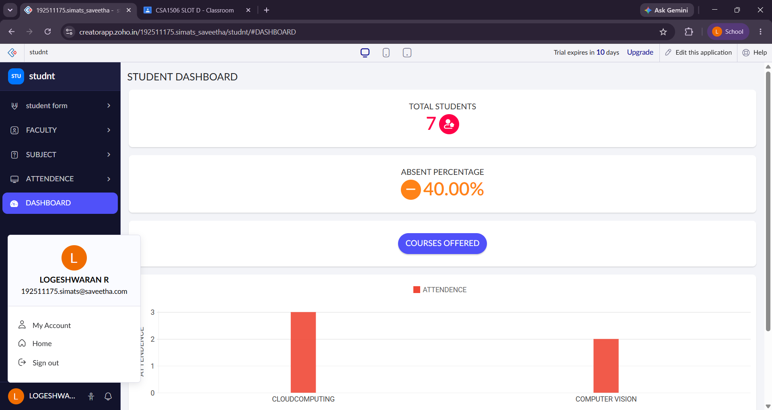

- STUDENT

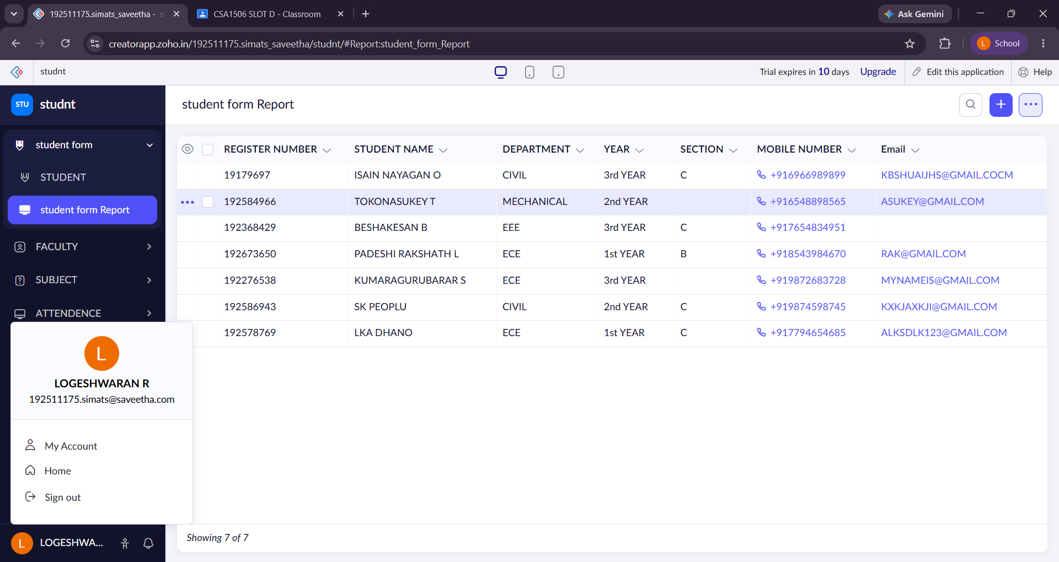
- SUBJECT
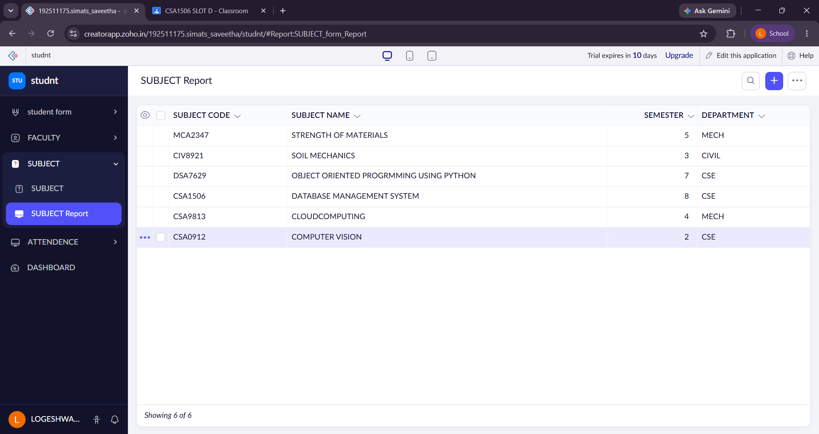

- ATTENDENCE
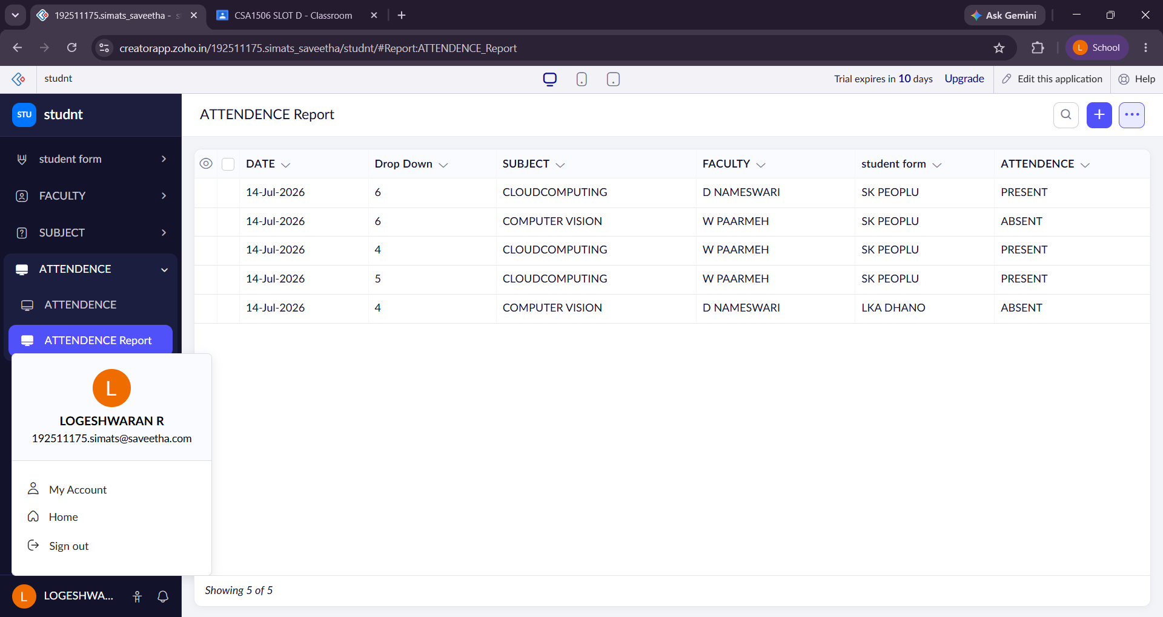

- FACULTY
